Project Synopsis on

**STUDENT ATTENDANCE MANAGEMENT**

**SYSTEM**

Submitted in partial fulfillment of the requirements for

the award of the degree of

**BACHELOR OF TECHNOLOGY**

in

**Information Technology**

by

Samir Kr. Tudu 20030480031

Kiran Kumari 20030485004

Baidujeet Deogam 20030480009

Under the Supervision

Of

**Prof. Bhawesh Kumar**

**Of**

**Computer Science and Engineering Department**



**DEPARTMENT OF COMPUTER SCIENCE AND ENGINEERING**

**BIT SINDRI, DHANBAD, JHARKHAND**

**INDIA, PIN-828123**

Contents:

**No. Page. no**

1. Introduction - 3

2. Literature Review - 4

3. Problem Statement - 5

4. Project Description - 6

5. Technical Requirements - 7

6. Data Flow Diagram - 10

7. Conclusion - 11

8. References - 12

Introduction:

Student Attendance Management System is a crucial aspect of educational institutions, allowing for accurate tracking of student presence and involvement in academic activities. Traditional paper-based systems can be cumbersome and prone to errors, leading to the development of digital solutions.

This literature review focuses on the development of a Student Attendance Management System (SAMS) using HTML, CSS, JavaScript, and MySQL. Due to this, there will be a quick attendance recording so that the faculties can easily mark attendance with a click or tap, no more tedious paperwork and they can easily generate reports to track individual and class attendance trends.

Literature Review:

Several studies have explored the use of web technologies in developing Student Attendance Management System.

[1] Y. B. Patil and S. M. Patil (2022) developed a SAMS using PHP, MySQL, and AJAX, demonstrating the benefits of real-time data updates and user interaction.

[2] M. A. Ansari, M. S. A. Siddiqui, and A. Khan (2021) proposed a SAMS using Laravel framework, emphasizing user authentication and data security.

[3] S. Singh, N. Singh, and D. P. Singh (2020) implemented a SAMS using Java, JSP, and MySQL, highlighting the ease of integration with existing database systems.

[4] S. G. Sonavane and S. R. Khandare (2019) developed a SAMS using PHP and MySQL, focusing on features like attendance reports and notification systems.

Problem Statement:

To develop a web-based Student Attendance Management System that can accurately and quickly record and identify the attendance of an individual student. The system should be able to create a secure database to store student information, attendance records, and related data.

The system aims to generate reports on individual student attendance, and class attendance. It helps to improve the efficiency and accuracy of student attendance tracking, provides valuable insights for educational institutions, and enhances overall administrative and academic processes. It reduces the errors associated with manual attendance tracking. The assigned faculties can easily mark the attendance of their respective classes.

Project Description:

The Student Attendance Management System is an independent project and does not depend on any other software or system. The product will automate various tasks associated with handling student details and organizing the stored information and optimum performance. Thus helping the Colleges to ensure the smooth working of these processes.

**System Functions:**

Our system has two types of accessing modes:

**Administrator:**

Administrators have the right to manage and manipulate student details, add a new student, provide register numbers for all students, assign each student a course, etc. Administrator can also add and assign teacher to a particular class, and update teachers' profile.

**Class Teacher:**

Teaching staffs have access to view the data stored in the database and can update the student's attendance in the form of formatted reports. Teachers has access to view the data stored in the database.

**Constraints:**

Interface is only in English language and no other language option is available. The user can log in with his assigned username and password, no guest facilities are available**.**

Technical Reqirements:

**1. Planning and Design**

* Define requirements: Gather detailed information about the system's functionalities and user needs.
* Create ER Diagram: Visually represent the relationships between database entities.
* Design user interface (UI): Sketch the layout and navigation for different user roles.

**2. Front-End Development**

* Develop HTML structure: Build the basic framework of the web pages.
* Implement CSS styles: Design the look and feel of the application.
* Add JavaScript functionality: Enhance user interaction and dynamic content.
* Integrate front-end components with the back-end.

**3. Back-End Development**

* Set up MySQL database: Create tables for storing student, attendance, and other relevant data.
* Develop PHP scripts: Implement functionalities like login, user management, attendance recording, and report generation.
* Connect front-end to back-end: Ensure smooth data exchange between user interface and database.

**4. Testing and Deployment**

* Thorough testing: Conduct comprehensive testing for functionality, usability, and security.
* Bug fixes: Address any issues identified during testing.
* Deployment: Publish the application online or on a local server.

**5. Maintenance and Support**

* Regular monitoring and maintenance.
* Adding new features and enhancements based on user feedback and evolving needs.

Technologies Used:

VS Code: Microsoft Visual Studio is an Integrated Development Environment (DE) from Microsoft.

HTML: Provides the basic structure and content of the web application.

CSS: Styles the appearance of the web application for a user-friendly interface.

JavaScript: Adds interactivity and dynamic behavior to the web application.

MySQL: Stores student data, attendance records, and other relevant information.

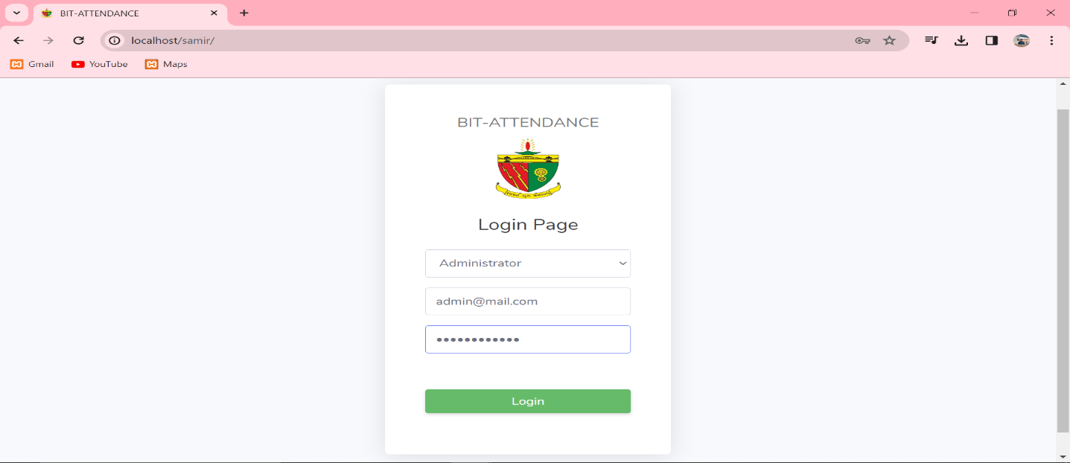

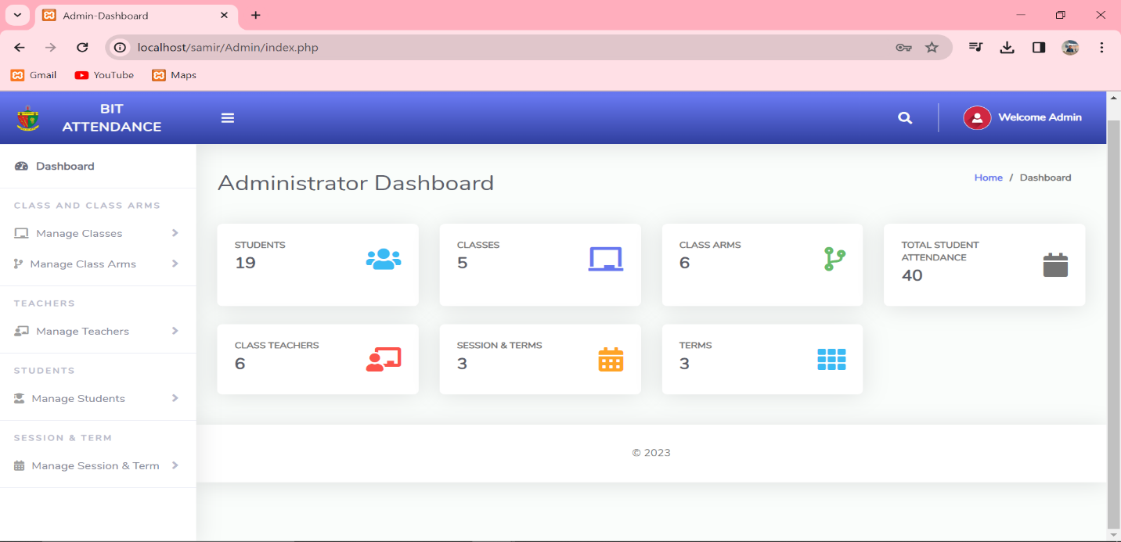

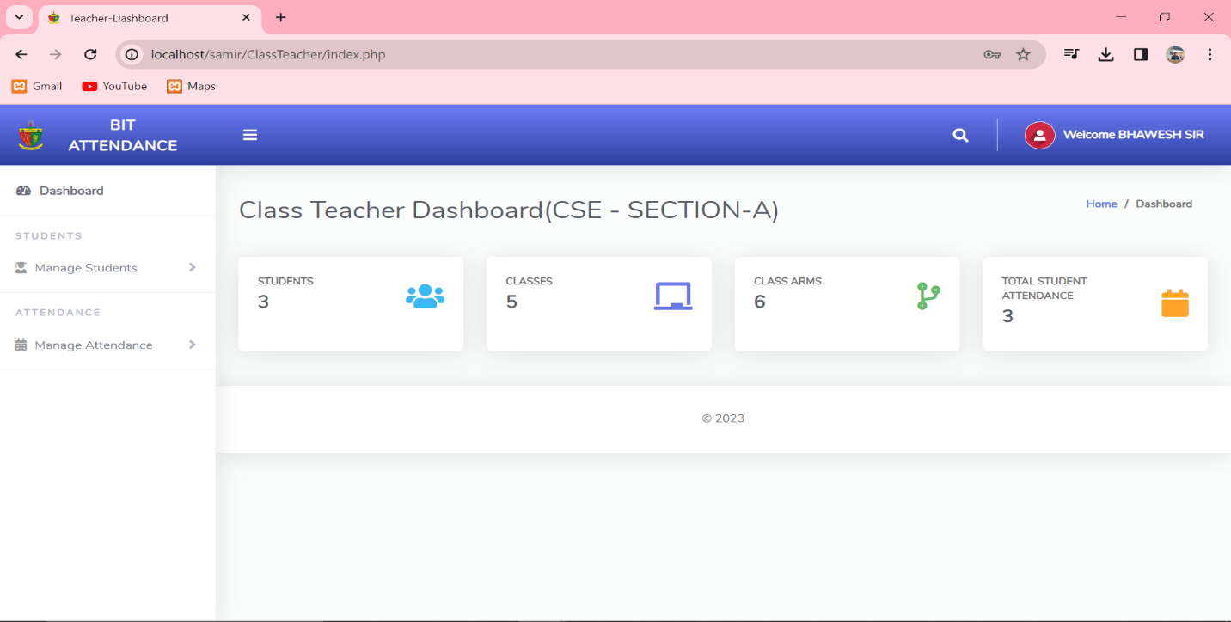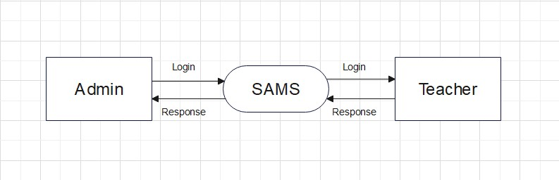Data Flow Diagram:

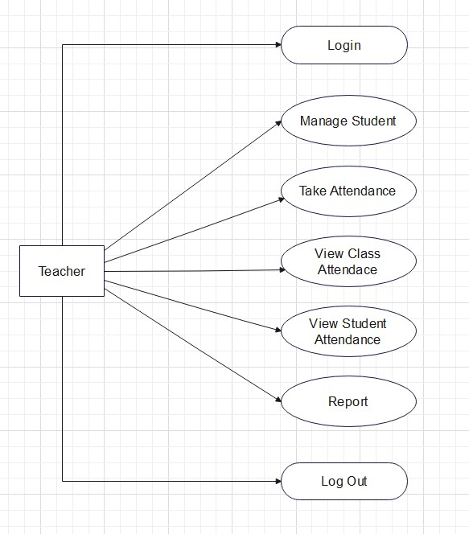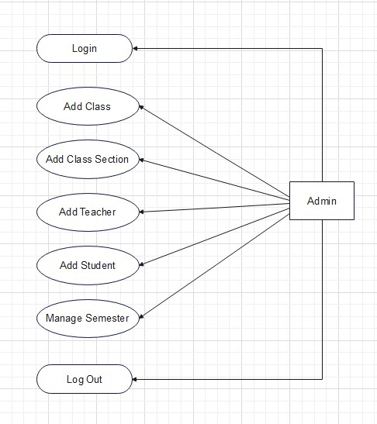

Login Diagram

Teacher- Data Flow Diagram

Admin- Data Flow Diagram

Conclusion:

In conclusion, the Student Attendance Management System stands as a transformative solution that not only modernizes attendance tracking but also contributes to the overall improvement of the educational experience.

The Student Attendance Management System (SAMS) plays an important role in education. It automates attendance, making tracking efficient and accurate. Real-time monitoring enables quick interventions for a better learning environment. With user-friendly features and seamless integration, it's easy for teachers and administrators. SAMS provides insightful reports and analytics, aiding data-driven decisions. It promotes accountability among students and transparency with parents. Overall, SAMS is a transformative tool, streamlining attendance and enhancing the educational experience for everyone involved.

References:

[1] Patil, Y. B., & Patil, S. M. (2022). Design and development of student attendance management system. International Journal of Scientific & Technology Research, 11(2), 3362-3368.

[2] Ansari, M. A., Siddiqui, M. S. A., & Khan, A. (2021). Development of web-based student attendance management system using Laravel framework. International Journal of Scientific & Technology Research, 10(1), 182-189.

[3] Singh, S., Singh, N., & Singh, D. P. (2020). Development of online student attendance management system using Java, JSP, and MySQL. International Journal of Advanced Research in Computer Science, 11(4), 71-77.

[4] Sonavane, S. G., & Khandare, S. R. (2019). Web-based student attendance management system using PHP and MySQL. International Journal of Advanced Research in Computer Science and Software Engineering, 9(4), 1-5.